1. Create a view named SMALL_CONDO. It consists of the location number, unit number, bedrooms, baths, condo fee, and owner number for every condo whose square footage is less than 1,100 square feet.
   1. Write and execute the CREATE VIEW command to create the SMALL_CONDO view. 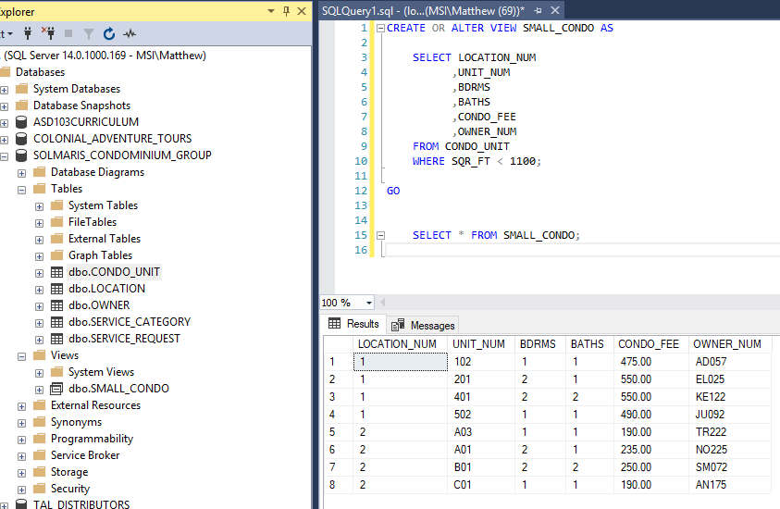
   2. Write and execute the command to retrieve the location number, unit number, and condo fee for every condo in the SMALL_CONDO view with a condo fee of $400 or more. 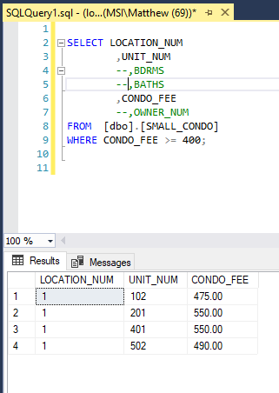
   3. Write and execute the query that the DBMS actually executes. 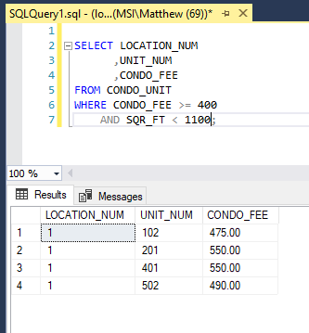
   4. Does updating the database through this view create any problems? If so, what are they? If not, why not?
      1. THE VIEW IS AN ISOLATED TABLE AND UPDATING IT WILL NOT AFFECT THE CONDO_UNIT TABLE
2. Create a view named CONDO_OWNERS. It consists of the location number, unit number, square footage, bedrooms, baths, condo fee, and owner’s last name for every condo in which the number of bedrooms is three.
   1. Write and execute the CREATE VIEW command to create the CONDO_OWNERS view. 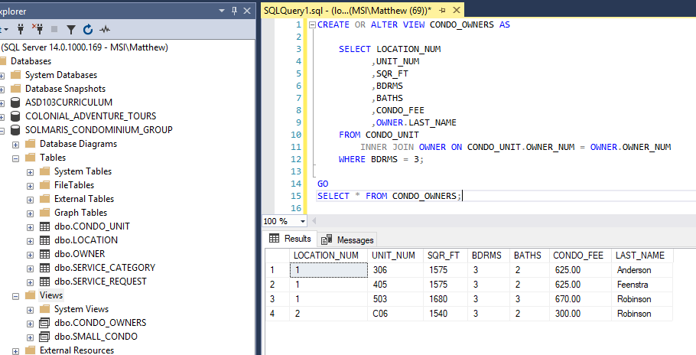
   2. Write and execute the command to retrieve the location number, unit number, condo fee, square footage, and owner’s last name for every condo in the CONDO_OWNERS view with a condo fee of less than $500. 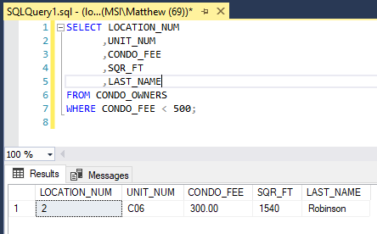
   3. Write and execute the query that the DBMS actually executes. 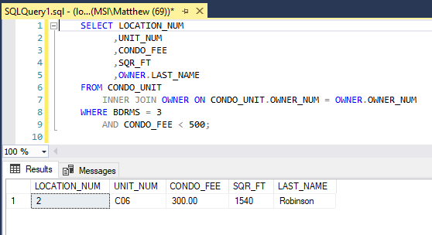
   4. Does updating the database through this view create any problems? If so, what are they? If not, why not?
      1. THE VIEW IS DERIVED FROM A JOINED TABLE, SO UPDATING ANY DATA CANNOT BE PERFORMED ON TH VIEW. IT MUST BE DONE TO THE TABLES IN REFERENCE.